ASSIGNMENT 05
PR26121077
01)
- Classes: Employee, Student, Person, Account, Bank
- Super Classes: Employee (for Manager, Worker), Student (for GraduateStudent, UndergraduateStudent), Person (for Student, Employee), Account (for SavingsAccount, CheckingAccount), Bank (for SBI, HNB, BOC)
- Sub Classes: Manager, Worker, GraduateStudent, UndergraduateStudent, SavingsAccount, CheckingAccount, SBI, HNB, BOC
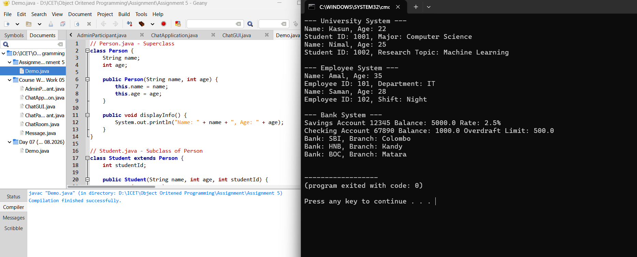

02)
Inheritance is a mechanism where a new class (subclass/child) derives properties and behaviors from an existing class (superclass/parent). It represents an "is-a" relationship.
Real-World Examples:
- Vehicle Hierarchy: Vehicle is the superclass. Car, Bike, and Truck are subclasses. All vehicles have wheels and an engine, but cars have four doors, bikes have two wheels, etc.
- Employee Hierarchy: Employee is the superclass. Manager, Developer, and Intern are subclasses. All employees have a name and salary, but managers have a team to manage, developers write code, etc.
- Animal Hierarchy: Animal is the superclass. Dog, Cat, and Bird are subclasses. All animals eat and sleep, but dogs bark, cats meow, and birds fly.
03)
How Inheritance Promotes Software Reuse, Saves Time, and Prevents Errors:
- Promotes Software Reuse: Common code (attributes and methods) is written once in the superclass. This code is automatically reused by all subclasses without rewriting it. This eliminates redundancy.
- Saves Time During Development: Developers don't need to start from scratch. They can quickly create new classes by extending existing, well-tested ones. This reduces the overall development time.
- Helps Prevent Errors:
  - Reduced Code Duplication: Bugs often arise from duplicate code. If a bug is found in the superclass, it is fixed in one place, and all subclasses automatically inherit the fix.
  - Reuse of Tested Code: By reusing existing code that has already been tested and debugged, the risk of introducing new bugs is significantly reduced.
04)
// Case 1: Student Hierarchy
class Student { /* ... */ }
class GraduateStudent extends Student { /* ... */ }
class UndergraduateStudent extends Student { /* ... */ }

// Case 2: Shape Hierarchy
class Shape { /* ... */ }
class Circle extends Shape { /* ... */ }
class Triangle extends Shape { /* ... */ }
class Rectangle extends Shape { /* ... */ }
class Sphere extends Shape { /* ... */ }
class Cube extends Shape { /* ... */ }

// Case 3: Loan Hierarchy
class Loan { /* ... */ }
class CarLoan extends Loan { /* ... */ }
class HomeImprovementLoan extends Loan { /* ... */ }
class MortgageLoan extends Loan { /* ... */ }

// Case 4: Employee Hierarchy
class Employee { /* ... */ }
class Faculty extends Employee { /* ... */ }
class Staff extends Employee { /* ... */ }

// Case 5: BankAccount Hierarchy
class BankAccount { /* ... */ }
class CheckingAccount extends BankAccount { /* ... */ }
class SavingsAccount extends BankAccount { /* ... */ }

05)
// Expand the Shape hierarchy:
class Shape {
// Generic Shape attributes like color, position
public void draw() { System.out.println("Drawing a shape."); }
public double area() { return 0; }
}

// Two-Dimensional Shapes
class TwoDimensionalShape extends Shape {
// Common 2D attributes like area calculation method
@Override
public double area() { return 0; } // to be overridden by specific 2D shapes
}

class Circle extends TwoDimensionalShape {
private double radius;
public Circle(double radius) { this.radius = radius; }
@Override
public double area() { return Math.PI * radius * radius; }
}
class Square extends TwoDimensionalShape {
private double side;
public Square(double side) { this.side = side; }
@Override
public double area() { return side * side; }
}
class Triangle extends TwoDimensionalShape { /* ... */ }
class Rectangle extends TwoDimensionalShape { /* ... */ }

// Three-Dimensional Shapes
class ThreeDimensionalShape extends Shape {
// Common 3D attributes like volume calculation method
public double volume() { return 0; }
}

class Sphere extends ThreeDimensionalShape {
private double radius;
public Sphere(double radius) { this.radius = radius; }
@Override
public double area() { return 4 * Math.PI * radius * radius; } // Surface area
@Override
public double volume() { return (4.0/3.0) * Math.PI * radius * radius * radius; }
}
class Cube extends ThreeDimensionalShape {
private double side;
public Cube(double side) { this.side = side; }
@Override
public double area() { return 6 * side * side; } // Surface area
@Override
public double volume() { return side * side * side; }
}

06)
Student
Id : int
Name : String
Study()

GraduateStudent
Advisor : String
Thesis : String
Doctoral
Masters
Sophomore

UdergraduateStudent
Year : int
Major : String
Freshman

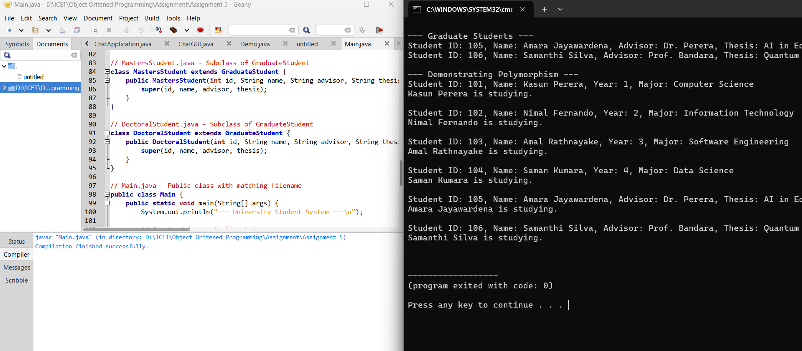

07)
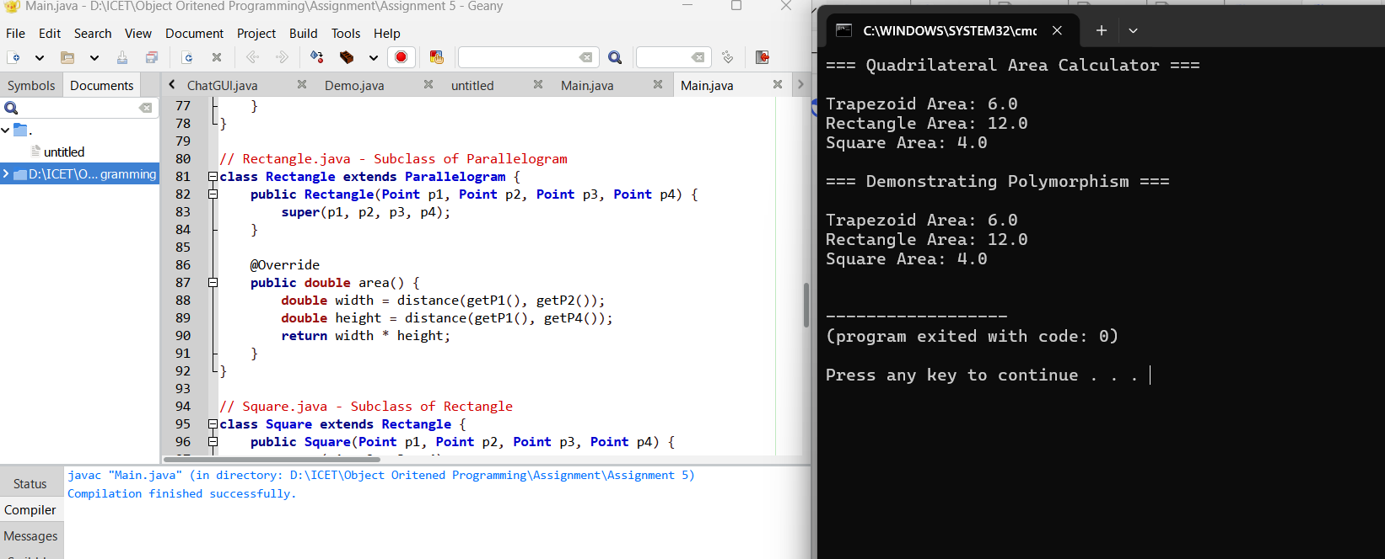

08)
Software Reusability in OOP using the Java Application:
- CalculatorView is a subclass of JFrame. By extending JFrame, it reuses all the pre-built functionality of a window in Java Swing (like setTitle, setSize, setVisible, setDefaultCloseOperation).
- This is a classic example of Inheritance. Without writing any complex code to create a window from scratch, CalculatorView automatically inherits all the methods and properties of JFrame.
- This saves development time, reduces errors, and promotes code reuse. The Demo class then creates an instance of CalculatorView and uses the inherited methods to configure and display the window.
09)
True Statements: A, B, C, D, E, F
- A: True. Inheritance promotes reuse.
- B: True. Java supports multiple inheritance of type (interfaces) but not of implementation.
- C: True. That's the definition of single inheritance.
- D: True. A subclass specializes the superclass.
- E: True. This is the foundation of polymorphism.
- F: True. A 'has-a' relationship is composition.

10)
Compile Error: Lines 4 and 5 in B.java.
- Line 4: printA(); will cause a compile error because class B does not extend class A, so B has no knowledge of the printA() method.
- Line 5: System.out.println("a:"+a); will cause a compile error because class B does not have a variable a. a is a member of class A.
11)
True Statements: B and C
- B: True. The relationship between a subclass and its superclass is an "is-a" relationship (e.g., Dog is a Animal).
- C: True. A class containing a reference to another class is a "has-a" relationship (e.g., Car has a Engine).
12)
True Statements: A, B, C, D
- A: True. Private members are not inherited.
- B: True. Constructors are not inherited.
- C: True. super(...) must be the first statement in a subclass constructor.
- D: True. This is method overriding.
- E: False. When a subclass redefines a method with the same signature (name and parameters), it is called overriding, not overloading. Overloading is when the parameters are different.
13)
Compile Statements: A, B
- A: Correct. This is method overriding with the exact same signature.
- B: Correct. The parameter name is different, but the signature (method name + parameter types) is the same. Java only cares about the parameter types, not the parameter names.
- C: Incorrect. Parameter type is double, so this is method overloading, not overriding. It will compile.
- D: Incorrect. Parameter type is int[], so this is method overloading, not overriding. It will compile.
Note: The question asks "Which statement(s), inserted at line 12, will compile". All four will compile. However, if the question specifically intended to refer to "overriding" (same signature), then only A and B correctly override the method.

14)
Compilation Error.
Explanation: Class B extends class A. Class A has a parameterized constructor A(int i). When a class doesn't have a default constructor (no-arg), the compiler does not provide one. Class B implicitly tries to call a default constructor of A (super()), which doesn't exist, causing a compile-time error.

15)
Compile Error Lines: 9, 10, 12, 13, 14, 15, 16, 17
Explanation:
- Inheritance Hierarchy: A (superclass) B extends A C extends A D extends B.
- Reference Variable Rule: A superclass reference variable can hold an object of any subclass (upcasting). A subclass reference variable cannot hold a superclass object.
- Line 9: B b2 = al; - B (subclass) trying to reference al (A object). Error.
- Line 10: b2 = cl; - B and C are siblings (both extend A). No relation. Error.
- Line 11: b2 = dl; - D is a subclass of B, so B b2 = d1; is allowed.
- Line 12: C c2 = al; - C (subclass) trying to reference al (A object). Error.
- Line 13: c2 = bl; - C and B are siblings. Error.
- Line 14: c2 = dl; - D is not a subclass of C. Error.
- Line 15: D d2 = al; - Error.
- Line 16: d2 = bl; - Error.
- Line 17: d2 = cl; - Error.

16)
Correct Answer: B
Explanation: Overriding is when a subclass provides a specific implementation for a method that is already defined in its superclass. The subclass method has the same name, same parameters, and same return type (or covariant). It "replaces" the superclass method's functionality for the subclass objects.

17)
Compile Statements: D
- A: Incorrect. If Animal doesn't extend Shape it's a circular dependency or undefined.
- B: Incorrect. This creates a circular inheritance (Shape extends Animal while Animal is outside).
- C: Incorrect. Java does not support multiple inheritance of classes.
- D: Correct. This creates a new class AnimalShape.
18)
Correct Answers: B, C, E
Explanation: Dynamic method dispatch (runtime polymorphism) is the mechanism where a call to an overridden method is resolved at runtime based on the type of the object the reference variable points to, not the type of the reference variable.
- A: a1.myMethod(100); - a1 refers to A object. Calls A's method.
- B: a2.myMethod(100); - a2 is A reference, but points to B object. Calls B's method. (Runtime Polymorphism)
- C: a3.myMethod(100); - a3 is A reference, points to C object. Calls C's method. (Runtime Polymorphism)
- D: b1.myMethod(100); - b1 refers to B object. Calls B's method.
- E: b2.myMethod(100); - b2 is B reference, points to C object. Calls C's method. (Runtime Polymorphism)
- F: c1.myMethod(100); - c1 refers to C object. Calls C's method.

19)
Compilation Error.
Explanation: Class Super does not have a default constructor. Class Sub extends Super, and the Sub constructor public Sub(int i){ System.out.println("Sub(int)"); } implicitly tries to call the default constructor of Super (super()), which does not exist. The Sub class must explicitly call the parameterized constructor of Super using super(i);.

20)
Compile Statements: E, F
Explanation: The super(...) call must be the first statement in the constructor. The arguments must be valid and accessible from the context of the constructor.
- A: super(a); - a is an instance variable of Super. It cannot be used in a super() call because super() must be the first statement, and instance variables of the superclass are not accessible to the subclass before the superclass constructor is called.
- B: super(b); - b is an instance variable of Sub. It cannot be used before the superclass constructor is called.
- C: super(x); - x is a static variable of Super. It can be used. The code will compile.
- D: super(y); - y is not defined anywhere.
- E: super(i); - i is the constructor parameter. It can be used. The code will compile.
- F: super(100); - This directly passes a value. The code will compile.

21)
Mechanism of Invoking a Superclass Constructor:
A subclass constructor must call its superclass's constructor to ensure the superclass part of the object is properly initialized. This is done using the super keyword.
- Rule: The super(...) call must be the first statement in the subclass constructor's body.
- Implicit Call: If the subclass constructor does not explicitly call super(...), the compiler inserts an implicit call to the superclass's default (no-argument) constructor (super()). If the superclass doesn't have a default constructor, a compile-time error occurs.
- Explicit Call: The subclass must explicitly call super(parameters) to invoke the parameterized constructor of its superclass.

22)
class Parent {
int value = 10;
}

class Child extends Parent {
int value = 20; // This hides Parent's value

void display() {
System.out.println(value); // 20
System.out.println(super.value); // 10
}
}

23) F. It is not possible to invoke test() method defined in C from a method in A.

24) Answer: F. hi hi, followed by an exception
25)

26)
Figure figref;
figref = r; // Rectangle object
System.out.println("Area is " + figref.area()); // Calls Rectangle's area()

figref = t; // Triangle object
System.out.println("Area is " + figref.area()); // Calls Triangle's area()

figref = f; // Figure object
System.out.println("Area is " + figref.area()); // Calls Figure's area()

27) A. ABDABCE

28)

29) D. none of the above

30) A, B, C are TRUE. D is FALSE.

31)
33) B, E, F will cause errors.
34)
import java.util.*;

class Customer {
private int code;
private String name;

public Customer(int code, String name) {
this.code = code;
this.name = name;
}

public int getCode() { return code; }
public String getName() { return name; }

@Override
public String toString() {
return code + "- " + name;
}
}

class CustomerStack {
private List<Customer> stack = new ArrayList<>();

public void push(Customer c) {
stack.add(c);
}

public Customer pop() {
if (!stack.isEmpty()) {
return stack.remove(stack.size() - 1);
}
return null;
}

public void printCustomerStack() {
List<String> result = new ArrayList<>();
for (int i = stack.size() - 1; i >= 0; i--) {
result.add(stack.get(i).toString());
}
System.out.println(result);
}
}
35) Answer: A. ABC
36) B and C are TRUE.
37) D. Prints Sub : null → Panadura

